Think like a Canadian economist
Episode 8. Infrastructure spending

VIDEO SCRIPT

Looking at the 2015 election platforms, political aspirants seem to be falling over each other to spend more on infrastructure.

The political consensus is echoed by a number of think tanks and organizations across the spectrum.

But what do economists really think about infrastructure investment in today’s context?

Here are 6 questions an economist would consider.

First, can infrastructure spending fight off a recession? Some argue infrastructure spending can play an important countercyclical fiscal policy role – in other words give a bit of a boost to the economy in times of economic slowdown. However, others argue the slowdown is driven by commodity prices changes and in this context, the effectiveness of fiscal policy is muted. Also, a general infrastructure program is unlikely to hit the weak parts of the economy, at the right time, in the right places.

Second, can the federal budget afford more infrastructure spending?
This might require deficit spending. Pushing the deficit toward $10 billion for two years amounts to 0.5% of GDP, which is small potatoes relative to our ability pay, and has virtually no impact on the long-run sustainability of our public finances.

Third, do public infrastructure projects pay sufficient returns?
Researchers have found public infrastructure makes workers and firms more productive, and the impact on quality of life might also be large.

Fourth, do interest rates affect the affordability of projects?
We want to compare a project’s internal rate of return – a measure of how much we benefit from the project - with the cost of funds, sometimes called a hurdle rate. As the government’s borrowing costs are currently at historic lows, more projects should now have returns exceeding the hurdle rate and get a financial thumbs up.

Fifth, are we already investing enough in infrastructure?
It’s useful to look at the time series of public infrastructure spending to get a sense of where we are. The chart shows that between 1981 and the onset of the financial crisis in 2008, government infrastructure investment bounced around three per cent per year. In response to the need for fiscal stimulus, Canada ramped up infrastructure spending until 2010. After that point, we fell back in the same range for investment we saw in previous decades. Given low costs of borrowing, you can argue that we should be investing much more today than we were in the 1980s and 1990s.

Sixth, should the federal government be doing this?
Some economists argue that the federal government ought to leave it to the provinces to choose and finance infrastructure projects, so it’s clear who is paying for what. However, local infrastructure can have national consequences.
For example, ports like Vancouver’s serve as national infrastructure, shipping out goods like Saskatchewan potash and prairie-grown wheat, durum, and canola. A federal government can properly account for cross-border externalities. Moreover, if the federal government takes on some more of the financial load for infrastructure, they can lighten the fiscal burden of the provinces.

Taking this all together, what should the next government do? That depends on how the six factors above are weighted, of course. But, it seems clear that a fairly strong economic case can be made for increasing the federal government’s role in infrastructure projects.

Follow us on twitter @tlcecon, and visit our website for more videos.

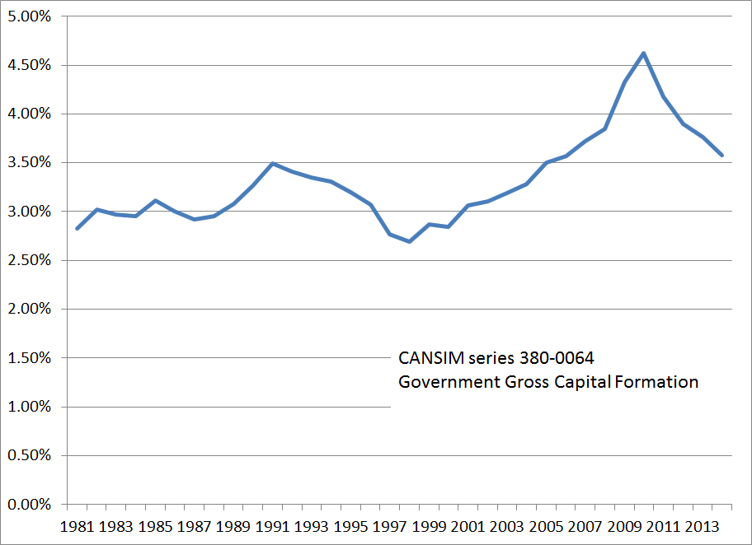

Suggested references and reading:

Kevin Milligan. Is there an economic case for more infrastructure spending?, Macleans, August 27, 2015.
http://www.macleans.ca/economy/economicanalysis/is-there-an-economic-case-for-more-infrastructure-spending/

Stephen Gordon. Increasing government spending would be the wrong solution to the wrong problem, National Post Full Comment, July 21, 2015. http://news.nationalpost.com/full-comment/stephen-gordon-increasing-government-spending-would-be-the-wrong-solution-to-the-wrong-problem

Stephen Gordon. What you need to know about infrastructure, Maclean’s February 22, 2014. http://www.macleans.ca/economy/economicanalysis/what-you-need-to-know-about-infrastructure/

Kevin Milligan. Why is David Dodge arguing for deficit spending? Maclean’s, June 23, 2014. http://www.macleans.ca/economy/why-is-david-dodge-arguing-for-deficit-spending/

Casey G. Vander Ploeg and Mike Holden. At the intersection, the case for sustained and strategic public infrastructure investment. Canada West Foundation Public Policy Brief, February 2013. http://cca-acc.com/pdfs/en/cca/AtTheIntersection2013.pdf

Joseph Heath. Why a conservative government would be bad for Ontario. June 9, 2014. http://induecourse.ca/why-a-conservative-government-would-be-bad-for-ontario/

Ethan Ilzetzki, Enrique G. Mendoza, Carlos A. Végh, How big (small?) are fiscal multipliers?, Journal of Monetary Economics, Volume 60, Issue 2, March 2013, Pages 239-254, ISSN 0304-3932, http://dx.doi.org/10.1016/j.jmoneco.2012.10.011.

